Abstract

# Introduction

## Problem Statement

## Data Source

# Exploratory Data Analysis

# Data Transformations

# Model Architecture

# Training

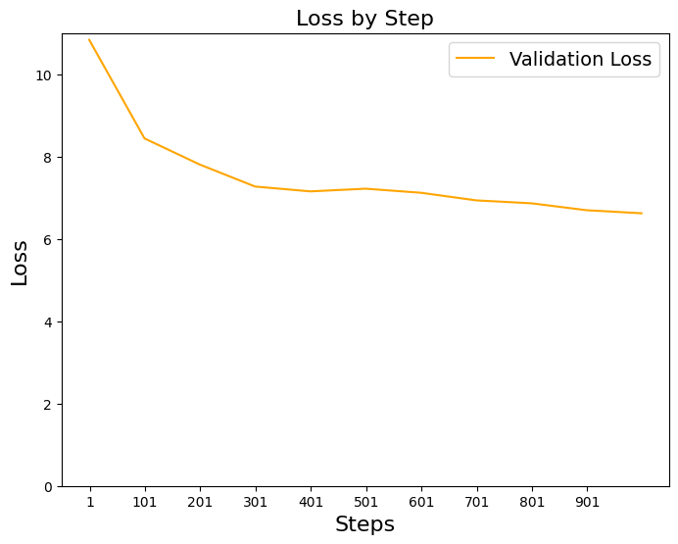

### References

[1] "FNSPID", Hugging Face, https://huggingface.co/datasets/Zihan1004/FNSPID/tree/main/Stock_news

[2] "Neural Networks: Zero to Hero", Andrej Karpathy, https://youtube.com/playlist?list=PLAqhIrjkxbuWI23v9cThsA9GvCAUhRvKZ&feature=shared

[3] "Attention Is All You Need", Vaswani et al., https://arxiv.org/abs/1706.03762

